Jose Santos
Student ID: l40033449
Assessment 2: Back End Development – Report

St Alphonsus RC Primary School Back End Website


Table of Contents
Contents
Introduction 2
Analysis of Technologies Used 2
Database Design 2
System Architecture & Sitemap 2
Design Justifications 2
Implementation of Key Features 2
Testing and Evidence 2
GitHub Repository Link 2
Conclusion 2

Introduction
This report outlines the development of a web-based digital information system for St Alphonsus Primary School. The school currently relies on paper-based methods to store important records such as student details, parents, teachers, and class information. These traditional methods are time-consuming, difficult to maintain, and prone to loss or errors.
As part of my role as a back-end web developer, I have been tasked with designing and creating a relational database and a supporting web application that will allow the school to store, manage, and update these records efficiently. This report explains the planning, design choices, implementation steps, testing, and evaluation of the final system.

Analysis of Technologies Used
Throughout the development of this system, multiple technologies were used, as different technologies provide different roles in supporting the systems functionality.
HTML
HTML was used to structure the website content, including pages, forms, and navigation.
CSS
CSS was used to style the system using a consistent colour scheme and responsive layout to improve usability.
JavaScript
JavaScript was used to add interactivity to forms, such as drop-down menus, improving user experience.
PHP
PHP was used as the server-side language to process form submissions, perform validation, and interact with the MySQL database securely.
MySQL
MySQL was used as the relational database management system to store all school records, including students, parents, teachers, classes, and login data.

Database Design
The database design uses a structured relational model to organise students, parents, teachers, and classes using primary and foreign keys. To achieve Third Normal Form (3NF), junction tables were introduced to resolve many-to-many relationships. A student–parents junction table removes the many-to-many relationship between students and parents, while a student–classes junction table allows students to enrol in multiple classes. The final design supports data integrity, reduces redundancy, and includes a login table to store authentication details.
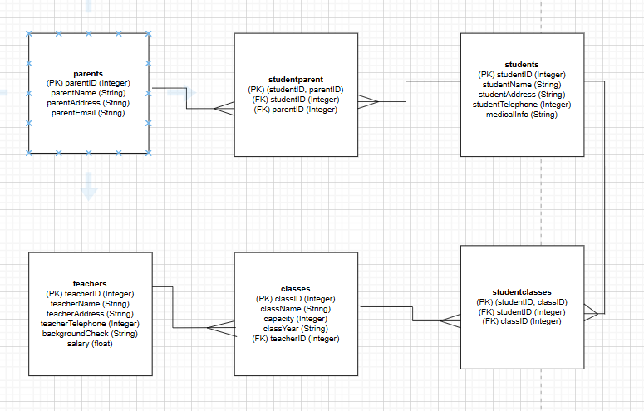

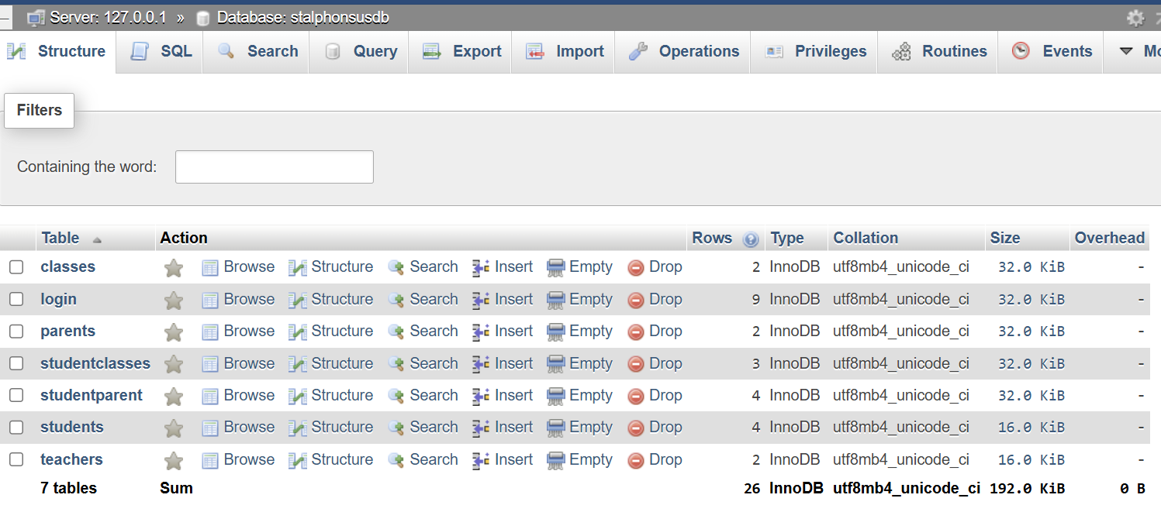

System Architecture & Sitemap
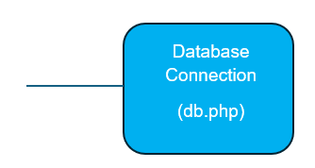
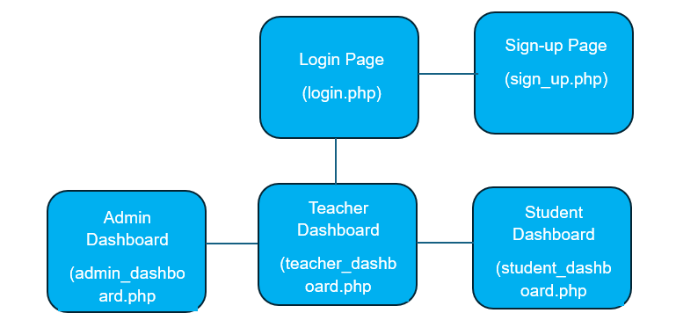
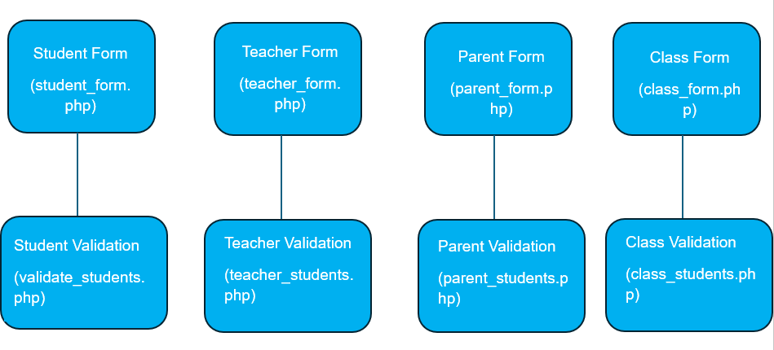
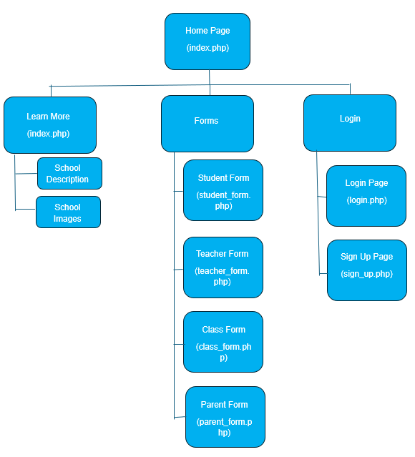
Sitemap

System Architecture
The system follows a three-tier architecture consisting of a presentation tier, an application (backend) tier, and a database tier. This structure separates user interaction, system logic, and data storage, improving security, maintainability, and scalability.
The presentation tier provides a web-based interface that allows students, teachers, and administrators to interact with the system through web pages, forms, and dashboards. Students can submit their own details along with their parents’ information, while teachers can manage their own data and assigned classes. User actions such as submitting forms or requesting data are sent to the backend, and the processed results are displayed to the user. Access to dashboards requires authentication through login and sign-up functionality, with available features depending on the user’s role.
The application (backend) tier acts as an intermediary between the presentation tier and the database. It handles database connections, processes user requests, applies business logic, and enforces security rules. This tier is also responsible for validating user input to ensure data integrity. For example, it checks for required fields and ensures email addresses follow a valid format before data is stored.
The database tier is responsible for storing all system data, including user accounts, student records, class information, and attendance data. The database is designed using Third Normal Form (3NF), with linked tables, primary keys, and foreign keys to reduce redundancy and maintain data consistency.

Design Justifications
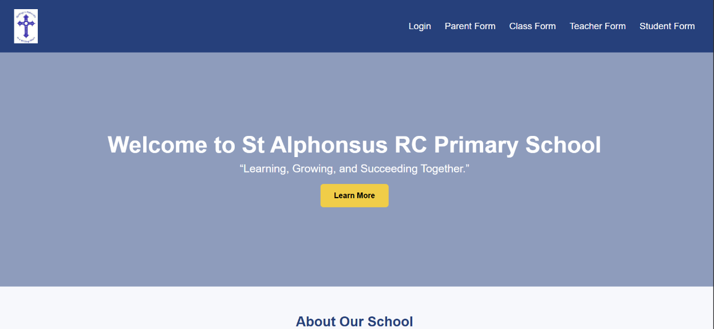
A simple blue and white colour scheme was chosen to reduce visual clutter and create a professional interface suitable for a primary school environment. Navigation buttons are positioned at the top of the page, following common school website layouts. Consistent colours, clearly sized input fields, and drop-down menus improve usability. Green and red submission messages with icons provide clear feedback to users.
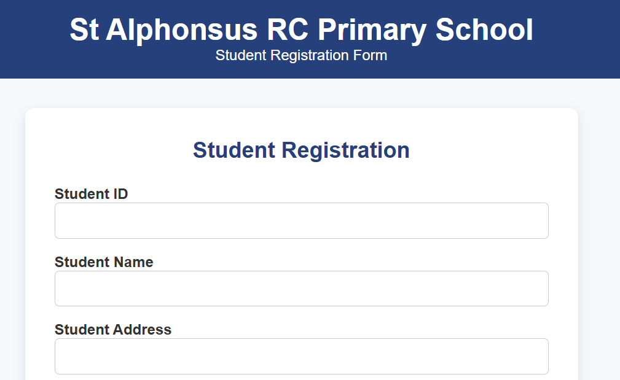
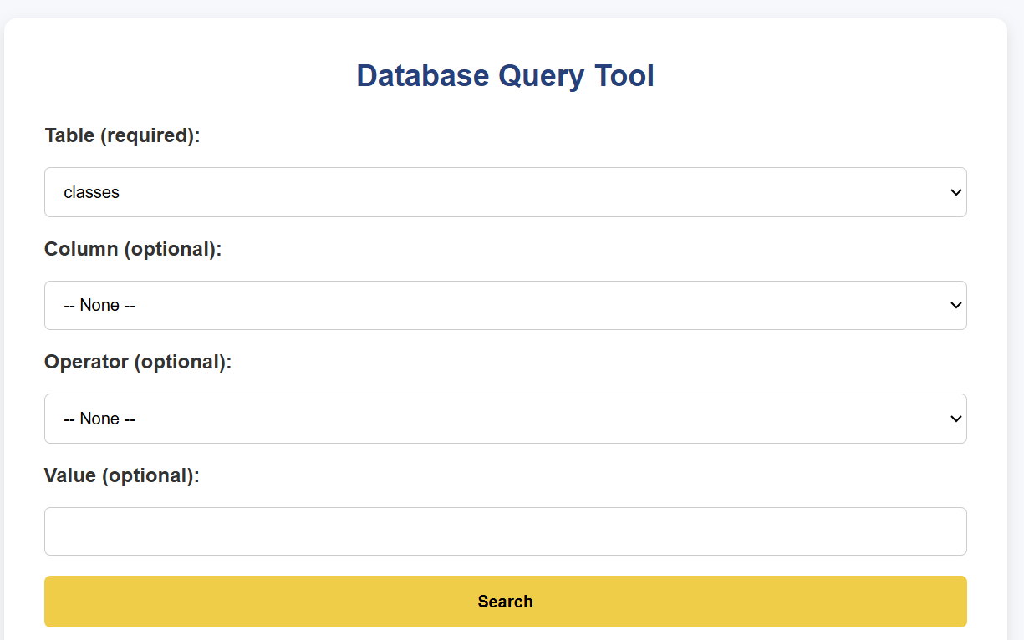


Implementation of Key Features
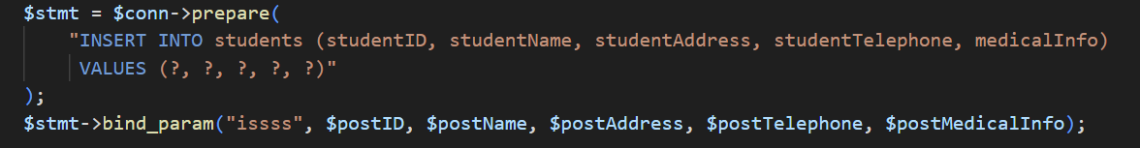
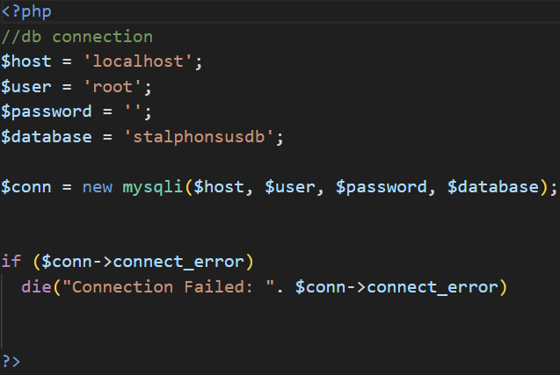
A key feature of the system is the secure insertion of data into the database. This required the implementation of a central database connection using PHP and MySQLi. Database credentials are stored in variables, improving maintainability, and a connection object is created to allow queries to be executed throughout the system. Error handling ensures the system does not proceed if the connection fails.

Prepared SQL statements are used to insert data securely into the database. These statements use placeholders and bind user input before execution, helping to prevent SQL injection and ensuring data is handled safely. This approach is used across all forms, including student records and user authentication.
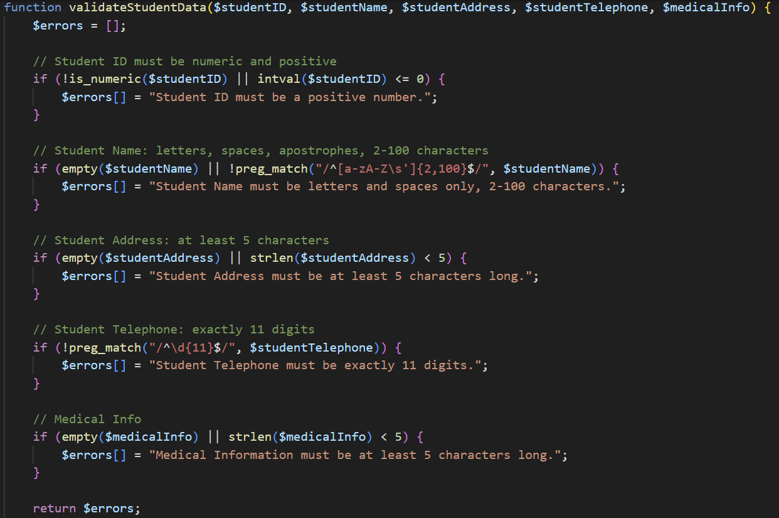
Server-side validation is implemented across all forms to ensure data integrity. Validation checks data types, formats, and minimum lengths before insertion. For example, telephone numbers must contain exactly 11 digits, preventing invalid contact details from being stored.
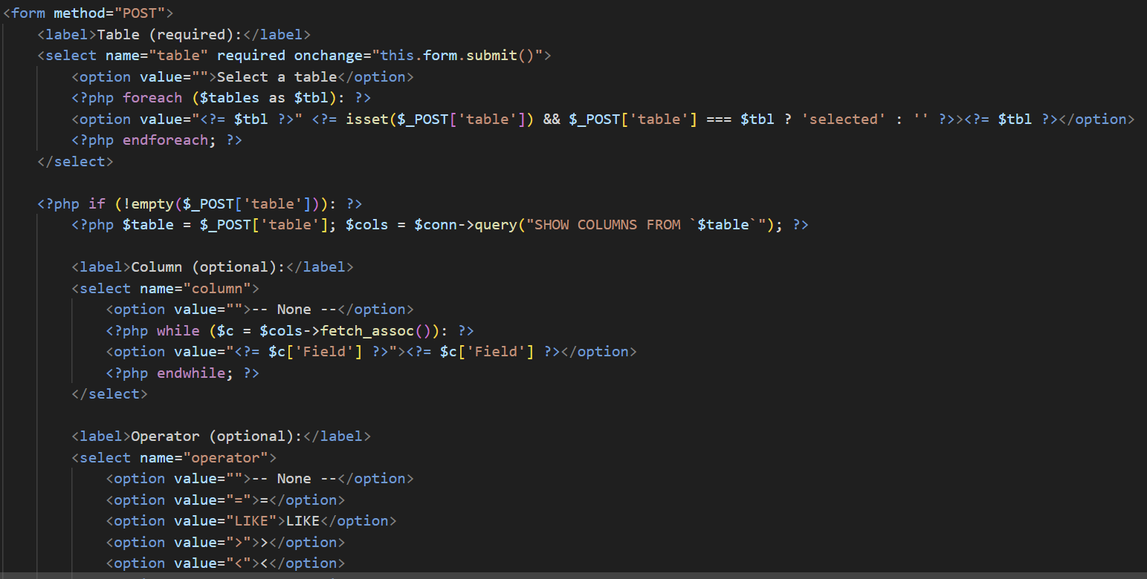
The system implements separate dashboards for administrators, teachers, and students, with access controlled through user roles stored in session variables. Each role is presented with features relevant to their permissions, ensuring secure and appropriate access to data.
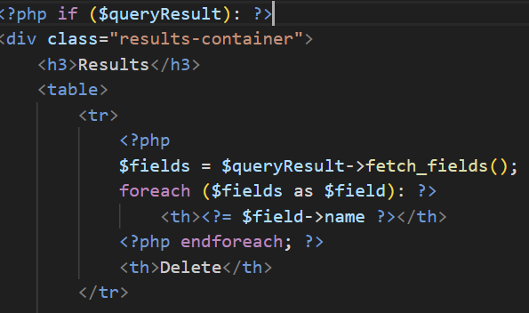
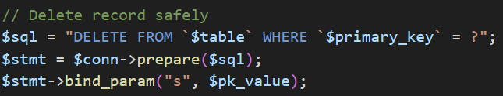
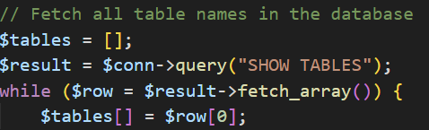
The admin dashboard provides advanced data management functionality. It dynamically retrieves all database tables and allows administrators to query records using selected columns, operators, and values. Prepared SQL statements are used to safely execute searches and prevent SQL injection. Query results are displayed in a table format, and administrators can securely delete records using a protected delete action with confirmation.
Teachers and students are provided with simplified dashboards that restrict access to administrative features, allowing them only to view or manage data relevant to their role. This role-based design improves security, usability, and data protection across the system.

Testing and Evidence
Test Description | Evidence
The dynamic website runs on a local server and connects to a MySQL database using a database connection file. | 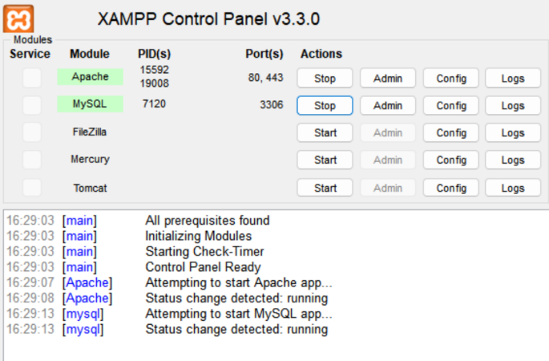  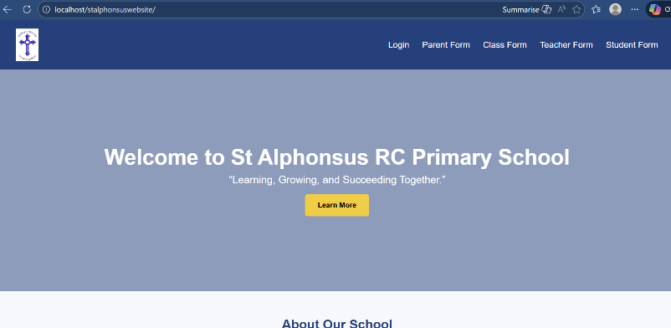  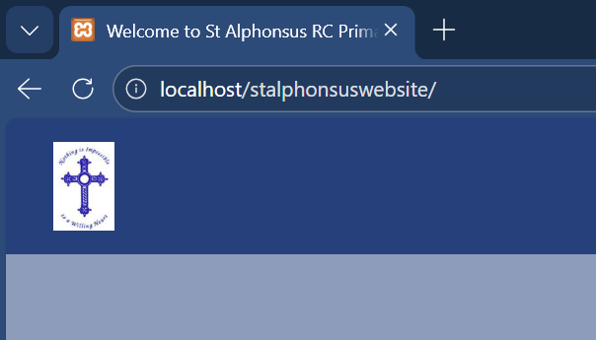  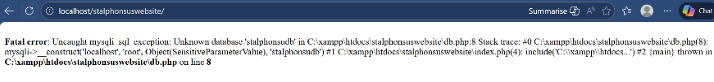  Runs without any errors. If wrong database name is used:
The home page (index) provides user interactivity, including navigation buttons for forms, login, and a “Learn More” section. | 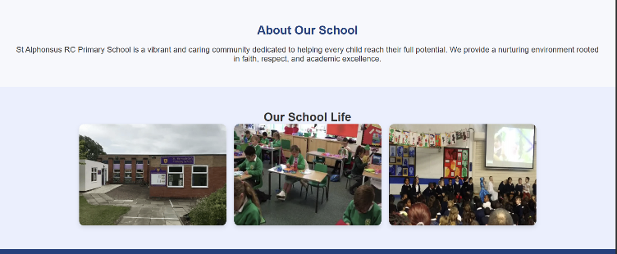  
Buttons link to correct form | 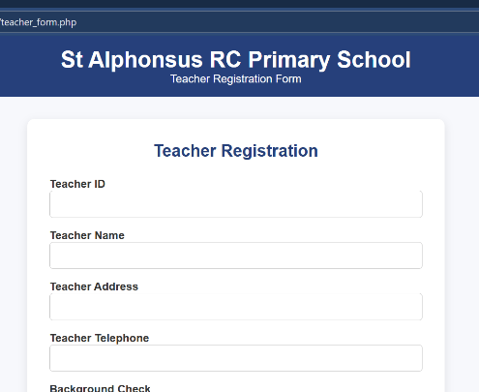  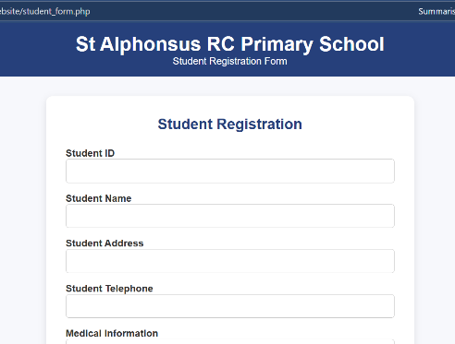  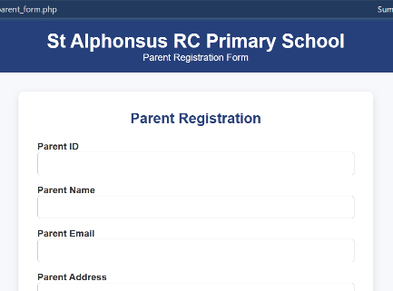  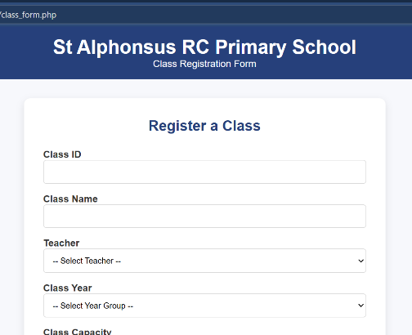  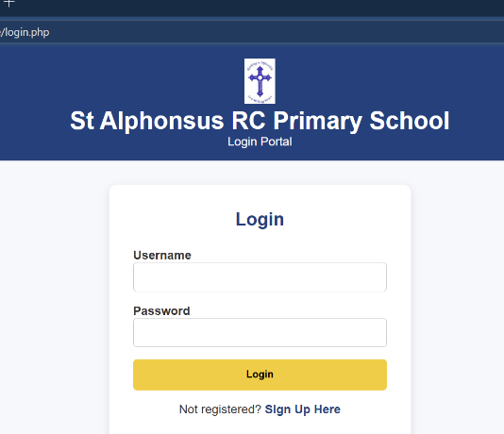
Input validation ensures only valid data is accepted | 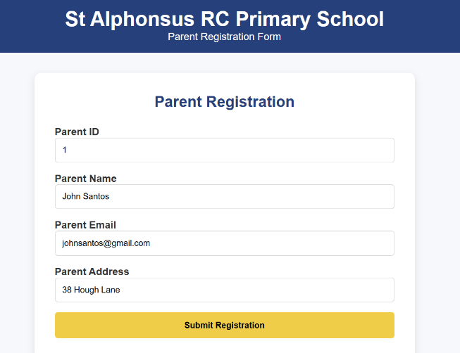  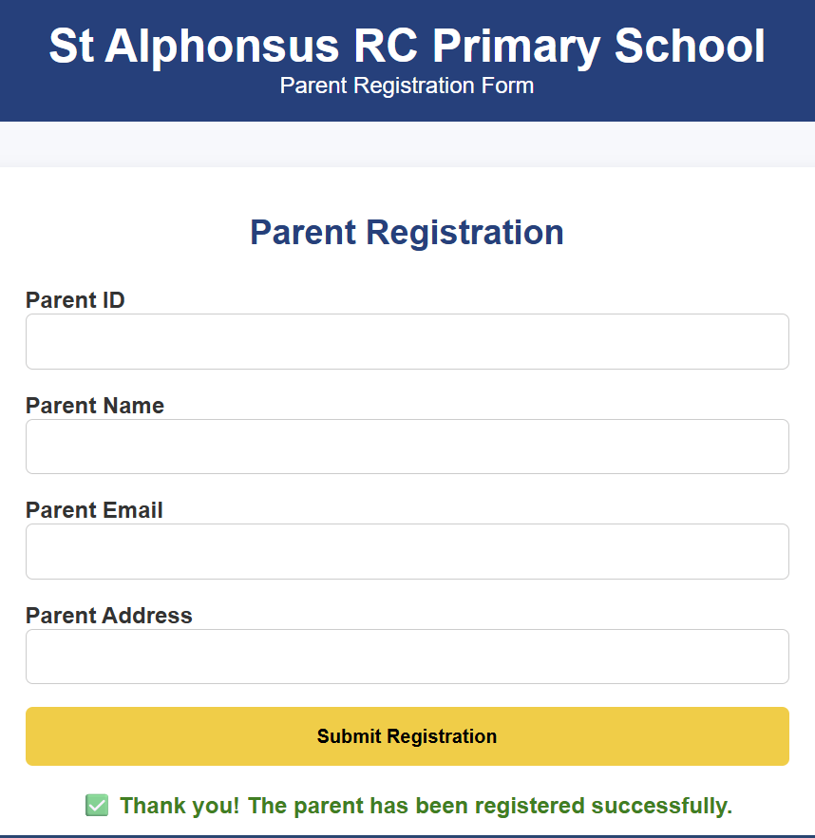  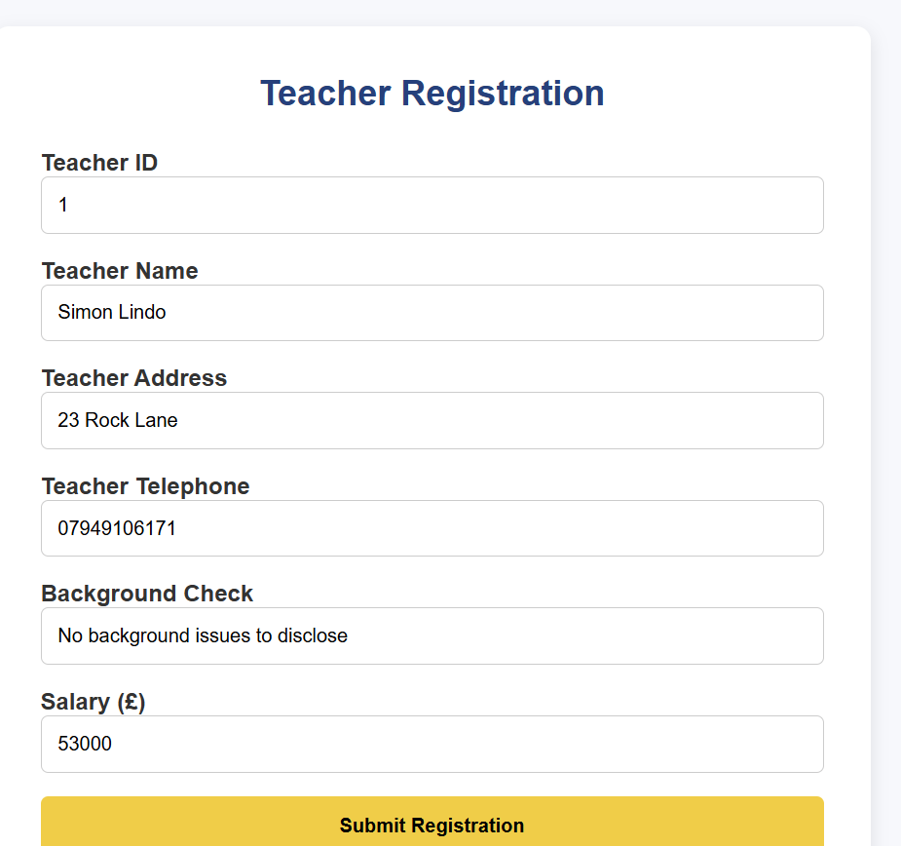  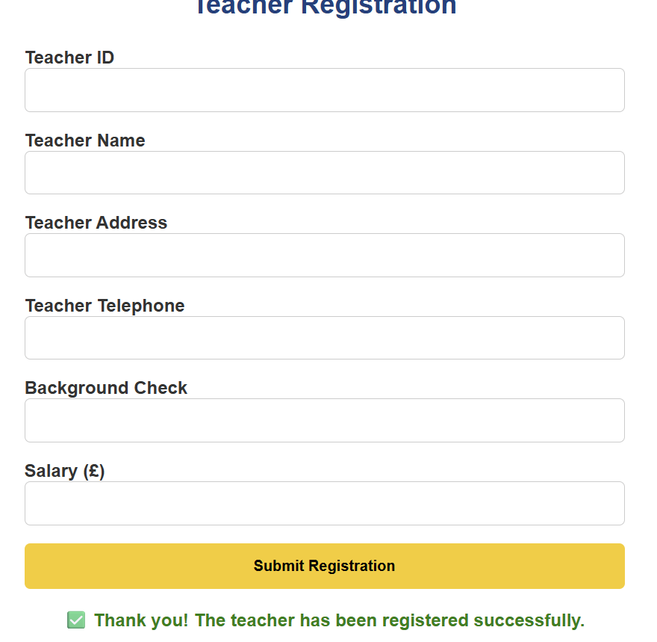  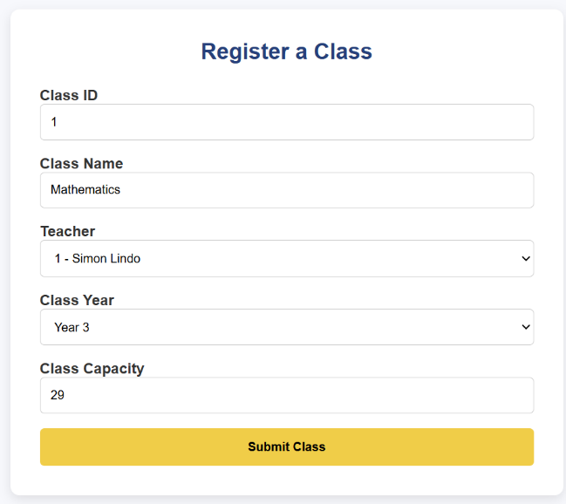  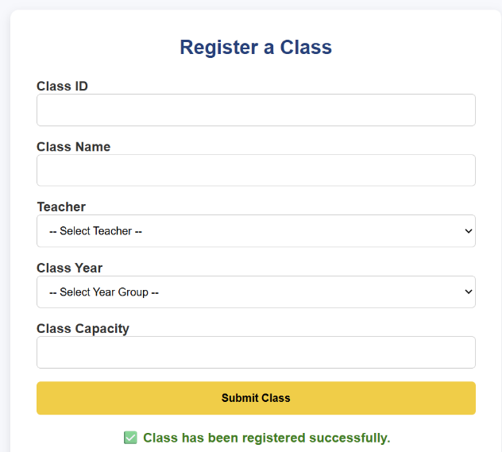  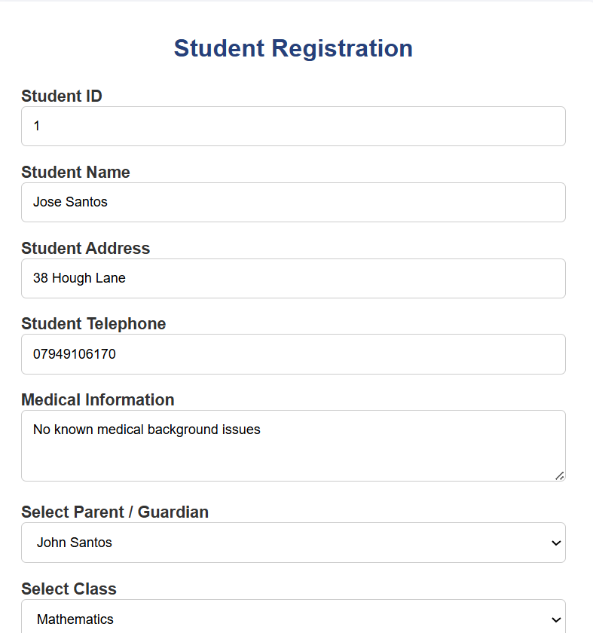  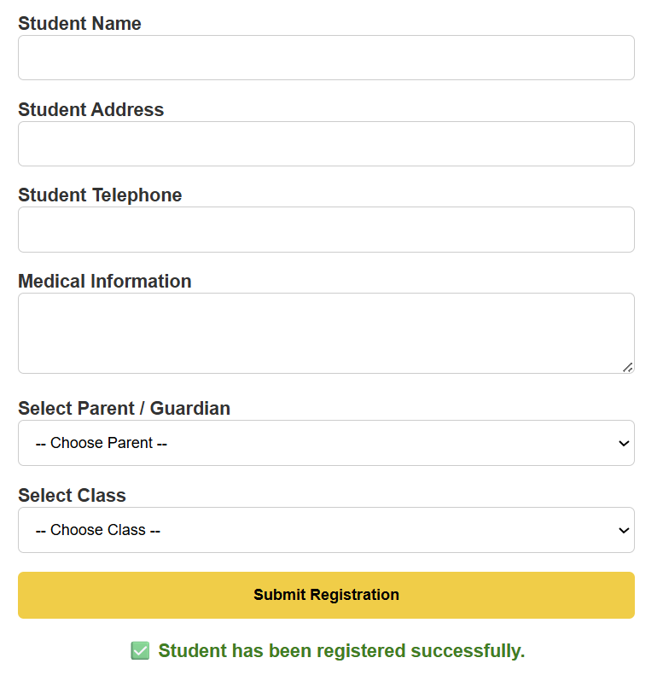
Invalid entries return appropriate error messages. | 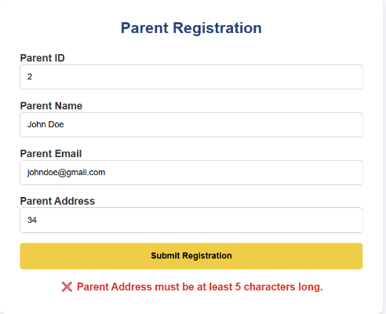  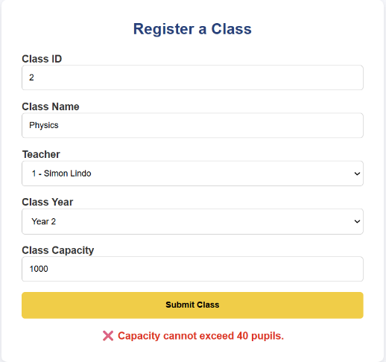  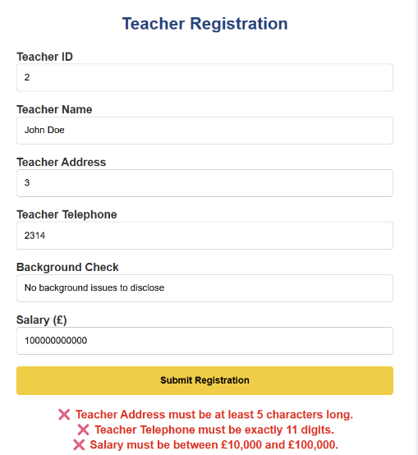  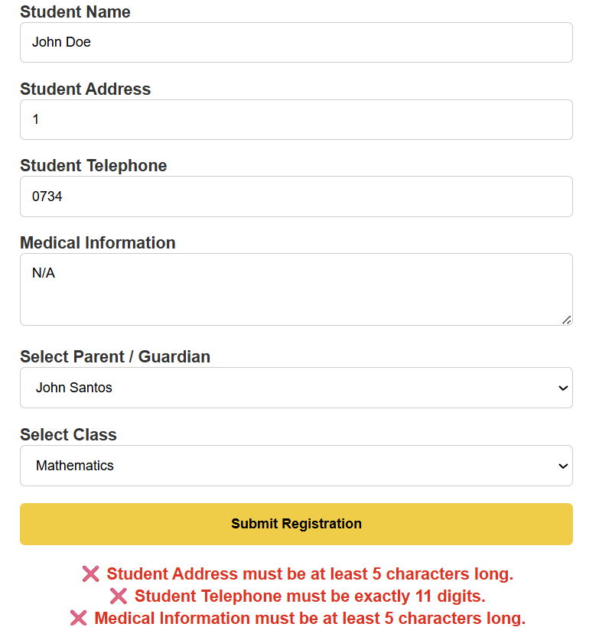
Successfully submitted data is inserted into the correct database tables and fields. | 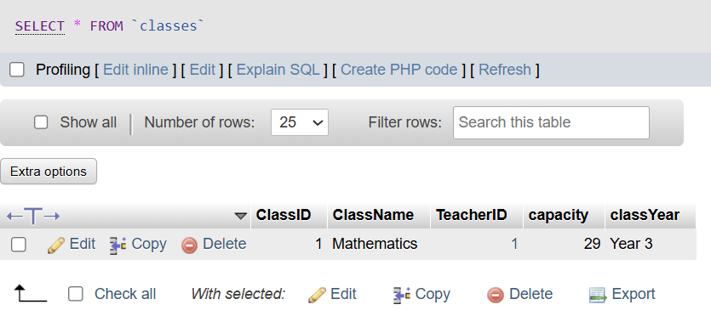  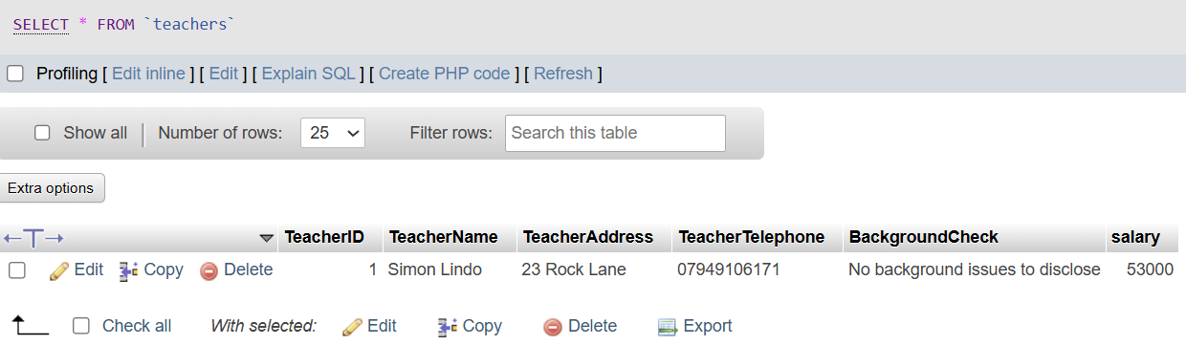  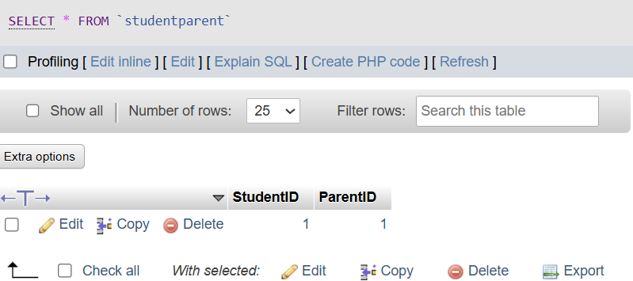  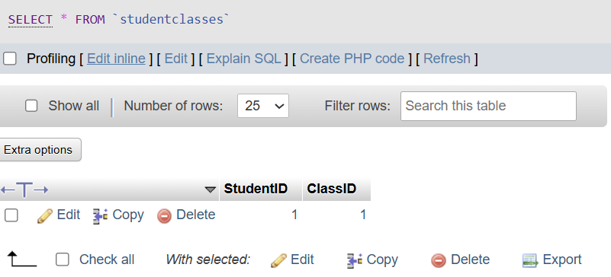  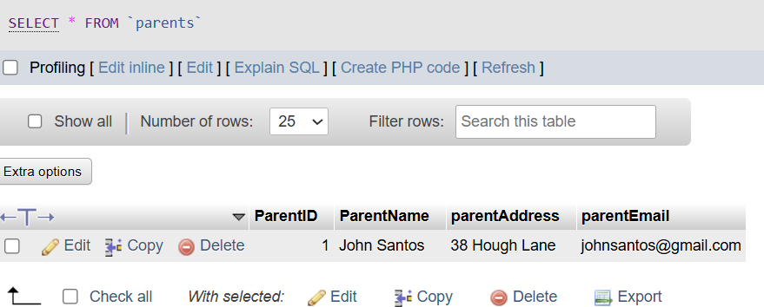  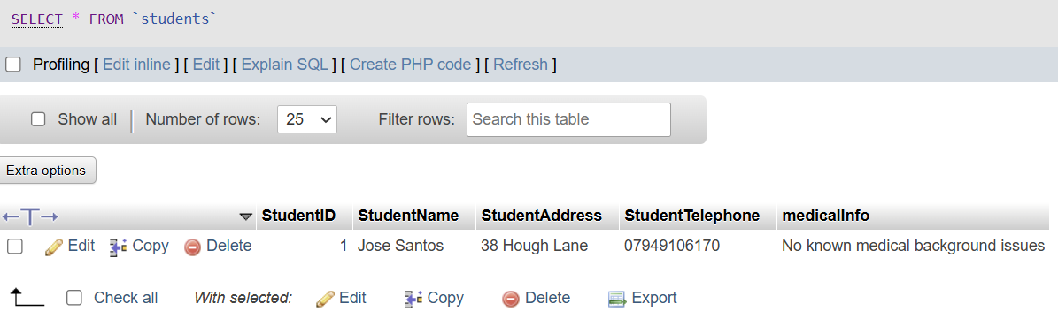
Users without an account can register using the sign-up feature. | 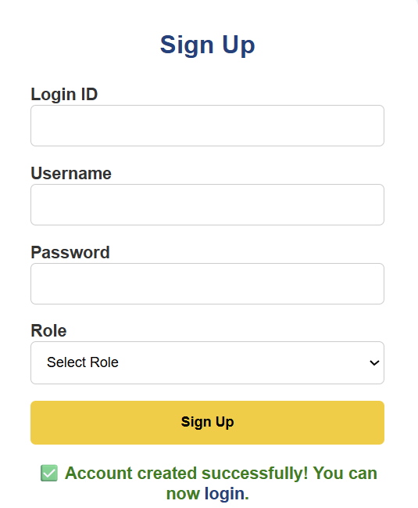  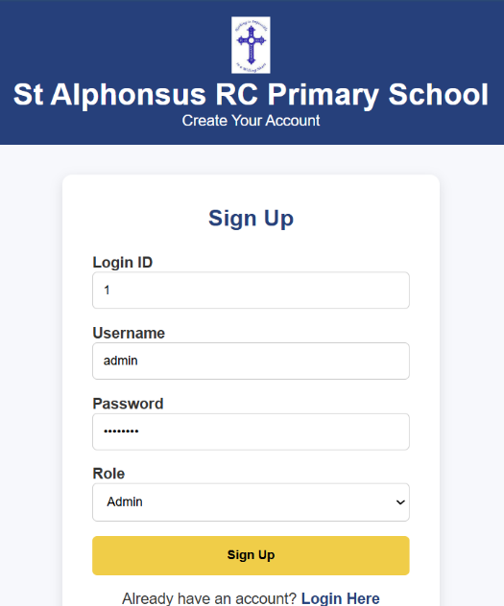
Passwords are securely hashed before storage. | 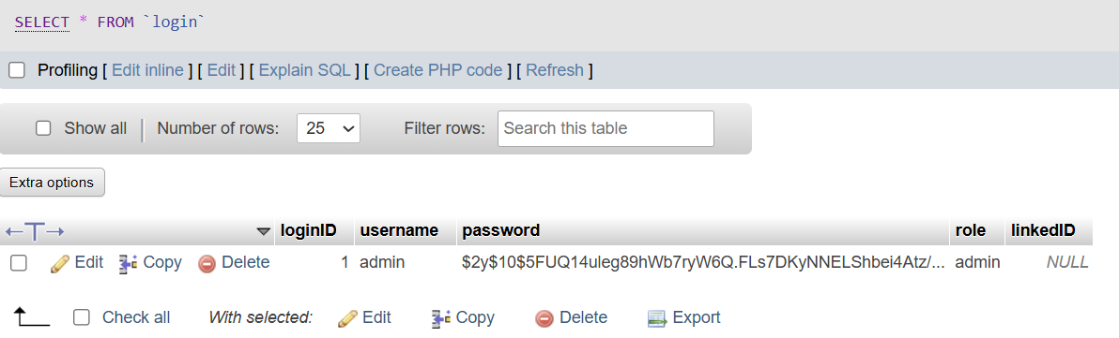
User authentication redirects users to role-specific dashboards. | 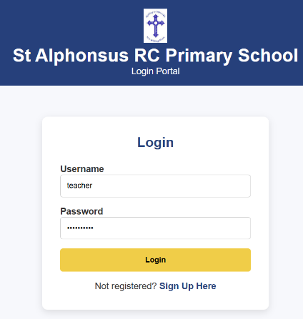  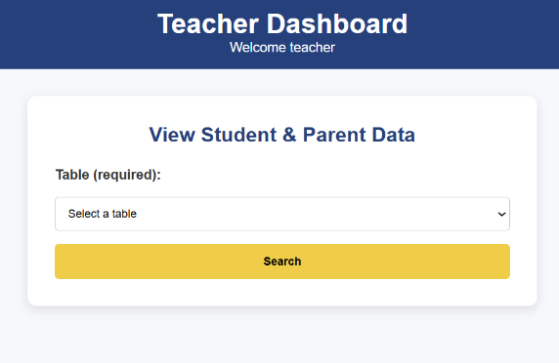  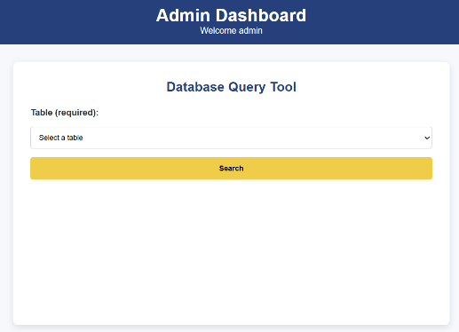  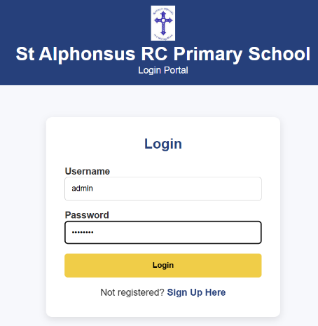  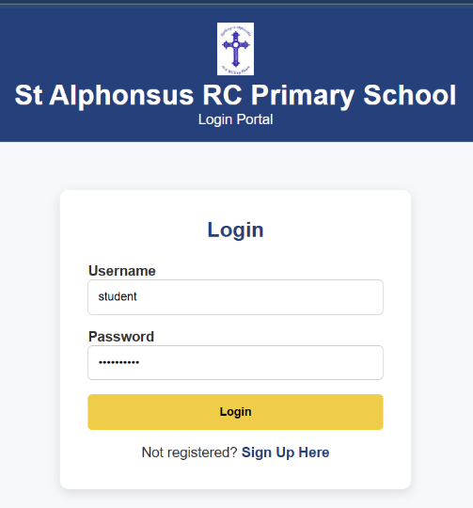  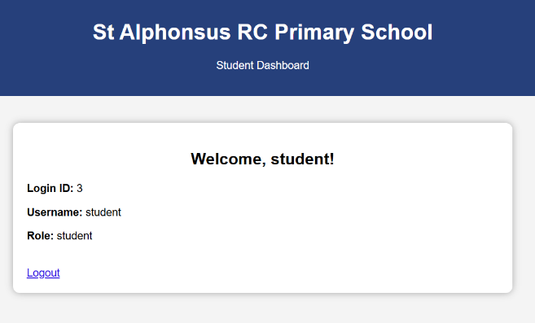
Admin users can view and delete records from all database tables. | 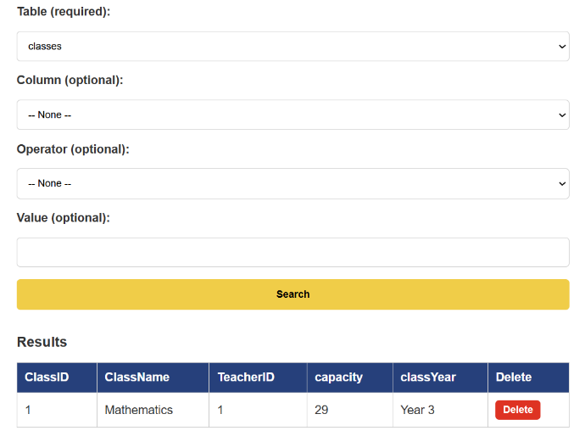
Teachers can view parent and student data. | 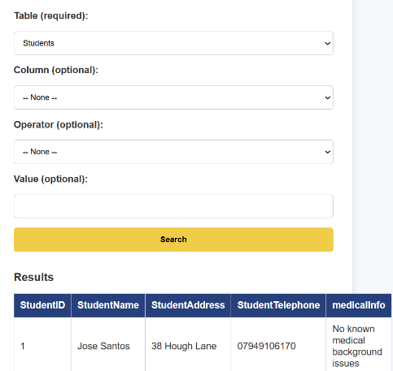  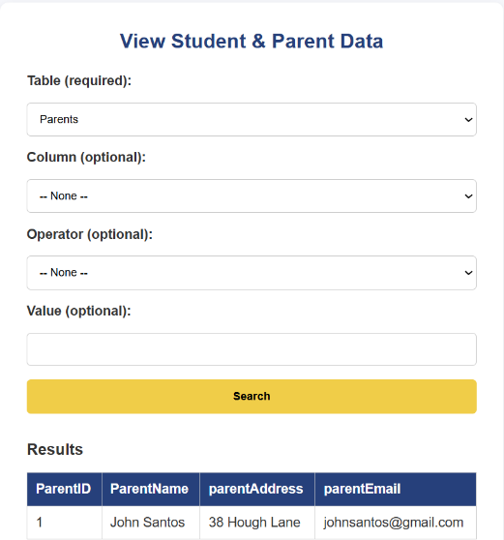
Students can view their own data.

GitHub Repository Link

Conclusion
In conclusion, the system successfully replaces paper-based records with a secure, efficient digital solution, meeting the functional and design requirements of a primary school environment.

